Код main.py
from fastapi import FastAPI, HTTPException
from pydantic import BaseModel
from typing import List, Optional
import sqlite3
app = FastAPI(title="Auction API")
# Database setup
def init_db():
conn = sqlite3.connect('auction.db')
cursor = conn.cursor()
cursor.execute('''
CREATE TABLE IF NOT EXISTS items (
id INTEGER PRIMARY KEY AUTOINCREMENT,
name TEXT NOT NULL,
description TEXT,
price REAL NOT NULL
)
''')
conn.commit()
conn.close()
init_db()
class Item(BaseModel):
id: Optional[int] = None
name: str
description: Optional[str] = None
price: float
@app.post("/items/", response_model=Item)
def create_item(item: Item):
conn = sqlite3.connect('auction.db')
cursor = conn.cursor()
cursor.execute('''
INSERT INTO items (name, description, price)
VALUES (?, ?, ?)
''', (item.name, item.description, item.price))
conn.commit()
item.id = cursor.lastrowid
conn.close()
return item
@app.get("/items/", response_model=List[Item])
def get_items():
conn = sqlite3.connect('auction.db')
cursor = conn.cursor()
cursor.execute('SELECT * FROM items')
rows = cursor.fetchall()
conn.close()
return [Item(id=row[0], name=row[1], description=row[2], price=row[3]) for row in rows]
@app.get("/items/{item_id}", response_model=Item)
def get_item(item_id: int):
conn = sqlite3.connect('auction.db')
cursor = conn.cursor()
cursor.execute('SELECT * FROM items WHERE id = ?', (item_id,))
row = cursor.fetchone()
conn.close()
if row is None:
raise HTTPException(status_code=404, detail="Item not found")
return Item(id=row[0], name=row[1], description=row[2], price=row[3])

auction_test.jmx
<?xml version="1.0" encoding="UTF-8"?>
<jmeterTestPlan version="1.2" properties="5.0" jmeter="5.6">
<hashTree>
<TestPlan guiclass="TestPlanGui" testclass="TestPlan" testname="Auction API Test Plan" enabled="true">
<stringProp name="TestPlan.comments">Test plan for FastAPI auction backend</stringProp>
<boolProp name="TestPlan.functional_mode">false</boolProp>
<boolProp name="TestPlan.serialize_threadgroups">false</boolProp>
<elementProp name="TestPlan.user_defined_variables" elementType="Arguments" guiclass="ArgumentsPanel" testclass="Arguments" testname="User Defined Variables" enabled="true">
<collectionProp name="Arguments.arguments"/>
</elementProp>
<stringProp name="TestPlan.user_define_classpath"></stringProp>
</TestPlan>
<hashTree>
<ThreadGroup guiclass="ThreadGroupGui" testclass="ThreadGroup" testname="Auction Users" enabled="true">
<stringProp name="ThreadGroup.on_sample_error">continue</stringProp>
<elementProp name="ThreadGroup.main_controller" elementType="LoopController" guiclass="LoopControlPanel" testclass="LoopController" testname="Loop Controller" enabled="true">
<boolProp name="LoopController.continue_forever">false</boolProp>
<stringProp name="LoopController.loops">1</stringProp>
</elementProp>
<stringProp name="ThreadGroup.num_threads">5</stringProp>
<stringProp name="ThreadGroup.ramp_time">10</stringProp>
<boolProp name="ThreadGroup.scheduler">false</boolProp>
<stringProp name="ThreadGroup.duration"></stringProp>
<stringProp name="ThreadGroup.delay"></stringProp>
<boolProp name="ThreadGroup.same_user_on_next_iteration">true</boolProp>
</ThreadGroup>
<hashTree>
<HeaderManager guiclass="HeaderPanel" testclass="HeaderManager" testname="HTTP Header Manager" enabled="true">
<collectionProp name="HeaderManager.headers">
<elementProp name="" elementType="Header">
<stringProp name="Header.name">Content-Type</stringProp>
<stringProp name="Header.value">application/json</stringProp>
</elementProp>
</collectionProp>
</HeaderManager>
<hashTree/>
<HTTPSamplerProxy guiclass="HttpTestSampleGui" testclass="HTTPSamplerProxy" testname="Create Item (POST)" enabled="true">
<elementProp name="HTTPsampler.Arguments" elementType="Arguments">
<collectionProp name="Arguments.arguments">
<elementProp name="" elementType="HTTPArgument">
<boolProp name="HTTPArgument.always_encode">false</boolProp>
<stringProp name="Argument.value">{
"name": "Item ${__threadNum}",
"description": "Description for item ${__threadNum}",
"price": 100.${__Random(10,99,)}
}</stringProp>
<stringProp name="Argument.metadata">=</stringProp>
</elementProp>
</collectionProp>
</elementProp>
<stringProp name="HTTPSampler.domain">127.0.0.1</stringProp>
<stringProp name="HTTPSampler.port">8000</stringProp>
<stringProp name="HTTPSampler.protocol">http</stringProp>
<stringProp name="HTTPSampler.path">/items/</stringProp>
<stringProp name="HTTPSampler.method">POST</stringProp>
<boolProp name="HTTPSampler.follow_redirects">true</boolProp>
<boolProp name="HTTPSampler.auto_redirects">false</boolProp>
<boolProp name="HTTPSampler.use_keepalive">true</boolProp>
<boolProp name="HTTPSampler.DO_MULTIPART_POST">false</boolProp>
<stringProp name="HTTPSampler.embedded_url_re"></stringProp>
<boolProp name="HTTPSampler.postBodyRaw">true</boolProp>
</HTTPSamplerProxy>
<hashTree>
<JSONPostProcessor guiclass="JSONPostProcessorGui" testclass="JSONPostProcessor" testname="Extract Item ID" enabled="true">
<stringProp name="JSONPostProcessor.referenceNames">ITEM_ID</stringProp>
<stringProp name="JSONPostProcessor.jsonPathExprs">$.id</stringProp>
<stringProp name="JSONPostProcessor.match_numbers">1</stringProp>
<stringProp name="JSONPostProcessor.defaultValues">0</stringProp>
</JSONPostProcessor>
<hashTree/>
</hashTree>
<HTTPSamplerProxy guiclass="HttpTestSampleGui" testclass="HTTPSamplerProxy" testname="Get All Items (GET)" enabled="true">
<elementProp name="HTTPsampler.Arguments" elementType="Arguments">
<collectionProp name="Arguments.arguments"/>
</elementProp>
<stringProp name="HTTPSampler.domain">127.0.0.1</stringProp>
<stringProp name="HTTPSampler.port">8000</stringProp>
<stringProp name="HTTPSampler.protocol">http</stringProp>
<stringProp name="HTTPSampler.path">/items/</stringProp>
<stringProp name="HTTPSampler.method">GET</stringProp>
<boolProp name="HTTPSampler.follow_redirects">true</boolProp>
<boolProp name="HTTPSampler.auto_redirects">false</boolProp>
<boolProp name="HTTPSampler.use_keepalive">true</boolProp>
<boolProp name="HTTPSampler.DO_MULTIPART_POST">false</boolProp>
</HTTPSamplerProxy>
<hashTree/>
<HTTPSamplerProxy guiclass="HttpTestSampleGui" testclass="HTTPSamplerProxy" testname="Get Item By ID (GET)" enabled="true">
<elementProp name="HTTPsampler.Arguments" elementType="Arguments">
<collectionProp name="Arguments.arguments"/>
</elementProp>
<stringProp name="HTTPSampler.domain">127.0.0.1</stringProp>
<stringProp name="HTTPSampler.port">8000</stringProp>
<stringProp name="HTTPSampler.protocol">http</stringProp>
<stringProp name="HTTPSampler.path">/items/${ITEM_ID}</stringProp>
<stringProp name="HTTPSampler.method">GET</stringProp>
<boolProp name="HTTPSampler.follow_redirects">true</boolProp>
<boolProp name="HTTPSampler.auto_redirects">false</boolProp>
<boolProp name="HTTPSampler.use_keepalive">true</boolProp>
<boolProp name="HTTPSampler.DO_MULTIPART_POST">false</boolProp>
</HTTPSamplerProxy>
<hashTree/>
<ResultCollector guiclass="ViewResultsFullVisualizer" testclass="ResultCollector" testname="View Results Tree" enabled="true">
<boolProp name="ResultCollector.error_logging">false</boolProp>
<objProp>
<name>saveConfig</name>
<value class="SampleSaveConfiguration">
<time>true</time>
<latency>true</latency>
<timestamp>true</timestamp>
<success>true</success>
<label>true</label>
<code>true</code>
<message>true</message>
<threadName>true</threadName>
<dataType>true</dataType>
<encoding>false</encoding>
<assertions>true</assertions>
<subresults>true</subresults>
<responseData>false</responseData>
<samplerData>false</samplerData>
<xml>false</xml>
<fieldNames>true</fieldNames>
<responseHeaders>false</responseHeaders>
<requestHeaders>false</requestHeaders>
<responseDataOnError>false</responseDataOnError>
<saveAssertionResultsFailureMessage>true</saveAssertionResultsFailureMessage>
<bytes>true</bytes>
<sentBytes>true</sentBytes>
<url>true</url>
<threadCounts>true</threadCounts>
<idleTime>true</idleTime>
<connectTime>true</connectTime>
</value>
</objProp>
<stringProp name="filename"></stringProp>
</ResultCollector>
<hashTree/>
<ResultCollector guiclass="SummaryReport" testclass="ResultCollector" testname="Summary Report" enabled="true">
<boolProp name="ResultCollector.error_logging">false</boolProp>
<objProp>
<name>saveConfig</name>
<value class="SampleSaveConfiguration">
<time>true</time>
<latency>true</latency>
<timestamp>true</timestamp>
<success>true</success>
<label>true</label>
<code>true</code>
<message>true</message>
<threadName>true</threadName>
<dataType>true</dataType>
<encoding>false</encoding>
<assertions>true</assertions>
<subresults>true</subresults>
<responseData>false</responseData>
<samplerData>false</samplerData>
<xml>false</xml>
<fieldNames>true</fieldNames>
<responseHeaders>false</responseHeaders>
<requestHeaders>false</requestHeaders>
<responseDataOnError>false</responseDataOnError>
<saveAssertionResultsFailureMessage>true</saveAssertionResultsFailureMessage>
<bytes>true</bytes>
<sentBytes>true</sentBytes>
<url>true</url>
<threadCounts>true</threadCounts>
<idleTime>true</idleTime>
<connectTime>true</connectTime>
</value>
</objProp>
<stringProp name="filename"></stringProp>
</ResultCollector>
<hashTree/>
</hashTree>
</hashTree>
</hashTree>
</jmeterTestPlan>

Сервер
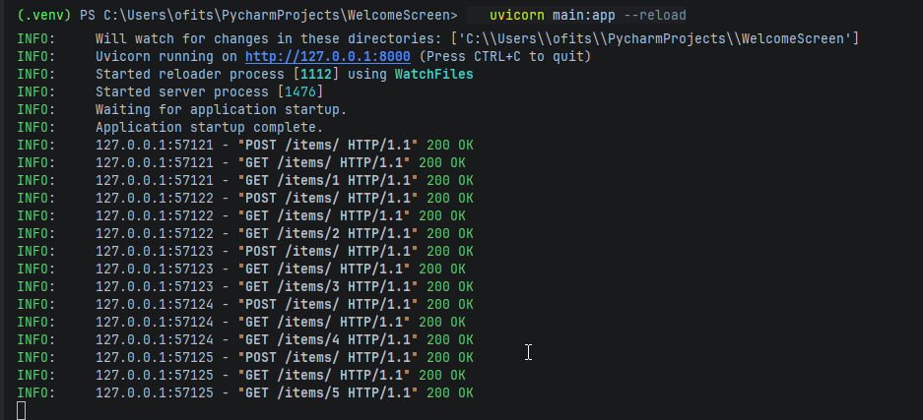

Отображение в jmeter
